H.T No
Regulations:
A17


Sreenidhi Institute of Science and Technology
(An Autonomous Institution)
Code No: 6C303 Date: 18-June-2019 (AN)

B.Tech II Year I-Semester External Examination, June-2019 (Supplementary)
Probability Theory and Stochastic Process (ECE and ECM)

Time: 3 Hours Max.Marks:75

Note: a) No additional answer sheets will be provided.
b) All sub-parts of a question must be answered at one place only, otherwise it will not be valued.
c) Missing data can be assumed suitably.

Part - A Max.Marks:25

Answer all QUESTIONS.

1. | Define joint probability for two events. | [3M]
2. | Define exponential random variable. | [3M]
3. | The joint Probability density function of and is  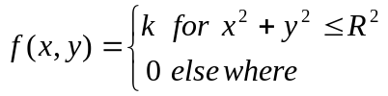  Compute . | [3M]
4. | Define discrete random process. | [3M]
5. | Define thermal noise. | [3M]
6. | Define narrowband process | [2M]
7. | Define statistically independent events. | [2M]
8. | Write the properties of joint distribution function. | [2M]
9. | Define time invariant linear system. | [2M]
10. | A random variable 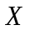 is Gaussian with a_{x} = 0 and σ_{x} = 1. What is the probability  that |X| > 2. | [2M]
Part – B Max.Marks:50
ANSWER ANY FIVE QUESTIONS. EACH QUESTION CARRIES 10 MARKS.

11. | a) | If 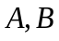 and are events such that 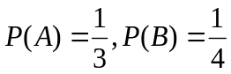and 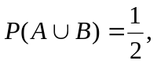  find (i) 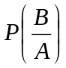 (ii) 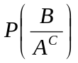 | [5M]
 | b) | In a bolt factory, machines and manufacture 20%, 30% and 50% of the total of their output and 6%, 3% and 2% are defective bolts respectively. A bolt is drawn at random and is found to be defective. Determine the probability that it was manufactured by machines 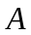. | [5M]
12. | a) | Define distribution function and write its properties | [5M]
 | b) | Determine the characteristic function of continuous density function  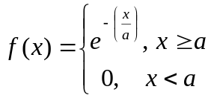 | [5M]
13. | a) | Given the function  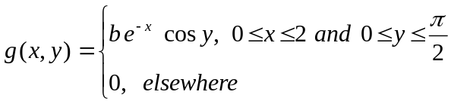  Compute the value of the constant so that 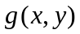is a valid probability density function | [5M]
 | b) | The joint probability density function of two random variables 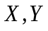 is given by  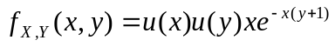.  Show that and are not independent. | [5M]
14. | a) | Let two random processes 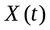and 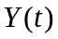be defined by  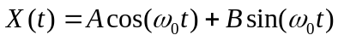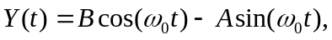  where A and B are random variables and 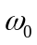 is constant. Find the cross-correlation function 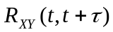 | [5M]
 | b) | Explain Autocorrelation function of a random process. | [5M]
15. | a) | Determine the average power of the random process 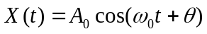 where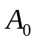and 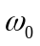 are constants and is a uniformly distributed random variable on 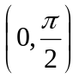 | [5M]
 | b) | Determine the relationship between cross-power spectral density and cross correlation function. | [5M]
16. | a) | Explain auto correlation function of response. | [5M]
 | b) | What are the causes of thermal noise? | [5M]
17. | a) | State and prove Bayes theorem. | [5M]
 | b) | If the probability density function of a random variable is given by  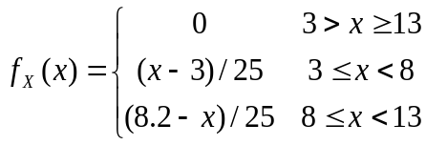  Compute the probability that has values greater than 4.5 but not greater than 6.7. | [5M]
18. | a) | Compute the power spectrum of a random process, whose auto correlation  function given by 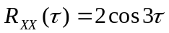. | [5M]
 | b) | Explain about Power Density Spectrum. | [5M]

-- 00 -- 00 –

